**Project Design Phase-II**

**Data Flow Diagram & User Stories**

|  |  |
| --- | --- |
| Date | 15 October 2022 |
| Team ID | PNT2022TMID07820 |
| Project Name | Project -SKILL/JOBS RECOMMENDED APPLICATION |
| Maximum Marks | 4 Marks |

**Data Flow Diagrams:**

A Data Flow Diagram (DFD) is a traditional visual representation of the information flows within a system. A neat and clear DFD can depict the right amount of the system requirement graphically. It shows how data enters and leaves the system, what changes the information, and where data is stored.

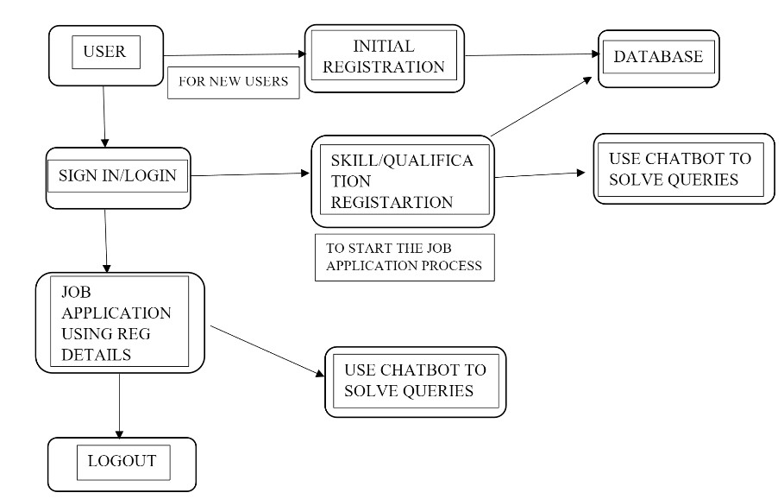

**User Stories :**

|  |  |  |  |  |  |  |
| --- | --- | --- | --- | --- | --- | --- |
| **User Type** | **Functional**  **Requirement**  **(Epic)** | **User Story**  **Number** | **User Story / Task** | **Acceptance criteria** | **Priority** | **Release** |
| Customer  (Mobile user) | Registration | USN-1 | As a user, I can register for the application by entering my email, password, and confirming my password. | I can access my account / dashboard | High | Sprint-1 |
|  |  | USN-2 | As a user, I will receive confirmation email once I have registered for the application | I can receive confirmation email & click confirm | High | Sprint-1 |
|  |  | USN-3 | As a user, I can register for the application through Facebook | I can register & access the dashboard with Facebook Login | Low | Sprint-2 |
|  |  | USN-4 | As a user, I can register for the application through Gmail | I can receive confirmation email & click confirm | Medium | Sprint-1 |
|  | Login | USN-5 | As a user, I can log into the application by entering email & password | I can access my account / dashboard | High | Sprint-1 |
|  | Dashboard | USN-6 | Create a model set that contains those models, then assign it to a role. | Assign that group to the appropriate roles on the Roles page | High | Sprint-1 |
| Customer (Web  user) | [Identity-Aware](https://console.cloud.google.com/security/iap) | USN-7 | Open, public access, User-authenticated access, Employee-restricted access. | Company public website. App running on the company intranet. App with access to customer private information. | High | Sprint-1 |
| Customer Care Executive | Communication | USN-8 | A customer care executive is a professional responsible for communicating the how's and why's regarding service expectations within a company. | For how to tackle customer queries. | Medium | Sprint-1 |
| Administrator | Device management | USN-9 | You can Delete/Disable/Enable devices in Azure Active Directory but you cannot Add/Remove Users in the directory. | Ease of use. | Medium | Sprint-1 |